*A DBMS Mini Project on*

**Training & Placement Portal**

*Submitted by*

**G. SuryaDev Reddy 14CO214**

**Chiranjeevi A.R Hegde 14CO207**

**V Sem B.Tech**

*in partial fulfillment for the award of the degree of*

**BACHELOR OF TECHNOLOGY**

*in*

**COMPUTER SCIENCE AND ENGINEERING**



**Department of Computer Science and Engineering**

**National Institute of Technology Karnataka, Surathkal**.

***November 2016***

Table of Contents

1. Abstract3
2. Introduction3
3. GUI Overview of the System4

3.1 Administrative User interface5

3.2 End user interface5

1. System Modules5

4.1 Admin Module5

4.2 Student Module8

4.3 Recruiter Module10

1. Software Specifications12
2. Non-Functional Requirements13
3. Database13
4. ER Diagram14
5. Relational Schema15
6. Future Enhancements16
7. Conclusion16

12.Bibliography17

1. **Abstract:**

Training and placement is the crucial part of any educational institute in which most of the work is being done manually .The aim of or project is Automation of Training and Placement until that will include minimum manual work and maximum optimization, abstraction security. This is web application which will help student as well as the administration authority to carry out each activity in this department.

This work present web portal designed for managing training and placement data. The objectie of this project is to develop a system that can be used by placement cell of a college. The purpose is to design a system that provides functionalities to perform the activities related to placement services. This system can be used as an application for the TPO of the college who manages the student information with regards to training and placement.

1. **Introduction:**

The web app for the training and placement cell of a college is a vital need for the students and the institute management for the purpose of proper placement and training of the students of the institute. It helps the students to provide their profiles to the training and placement cell of the institute, update their respective profiles (with their gradual approach towards course end), get to know about the companies coming for the on campus interviews. Under this system all the students of the ongoing (current) batches of various streams can register their profiles. The training and placement cell (t/p cell) remains in continuous touch with all the students of the institute time-to-time. This dedicated application for the institute's t/p cell can be expanded to the various machines in the institute and can be accessed by the students as well as by the administrator (TPO in charge). The system remains connected with the profile databases of the various students to continuously monitor the variety of scopes available for the students' placement. The companies will also be in touch with the T&P providing information from time to time.

1. **GUI Overview of the system:**

To provide flexibility to the users, the interfaces have been developed that are accessible through a browser. The GUI’S at the top level have been categorized as

1. ***Administrative user interface***
2. ***End user interface***

***3.1 Administrative user interface:***

The ‘*administrative user interface’* concentrates on the consistent information that is practically, part of the organizational activities and which needs proper authentication for the data collection. These interfaces help the administrators with all the transactional states like Data insertion, Data deletion and Data updation along with the extensive data search capabilities.

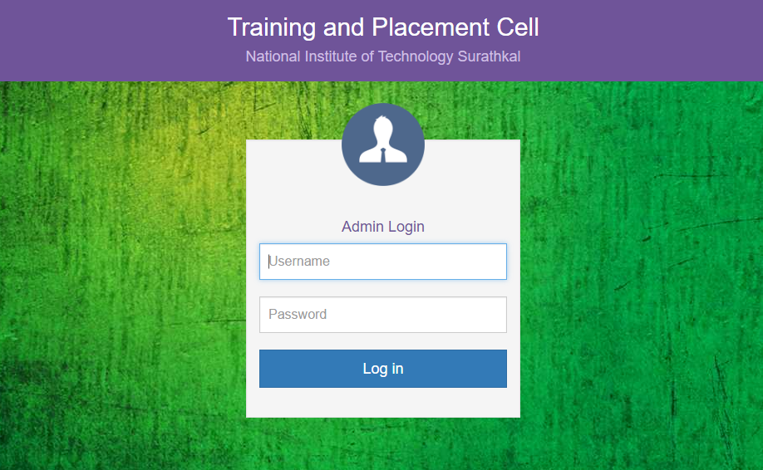

***3.2 End User interface:***

The ‘*End user interface’* helps the students and recruiters who are end users of the system in transactions through the existing data and required services. The operational user interface also helps the users in managing their own information in a customized manner.

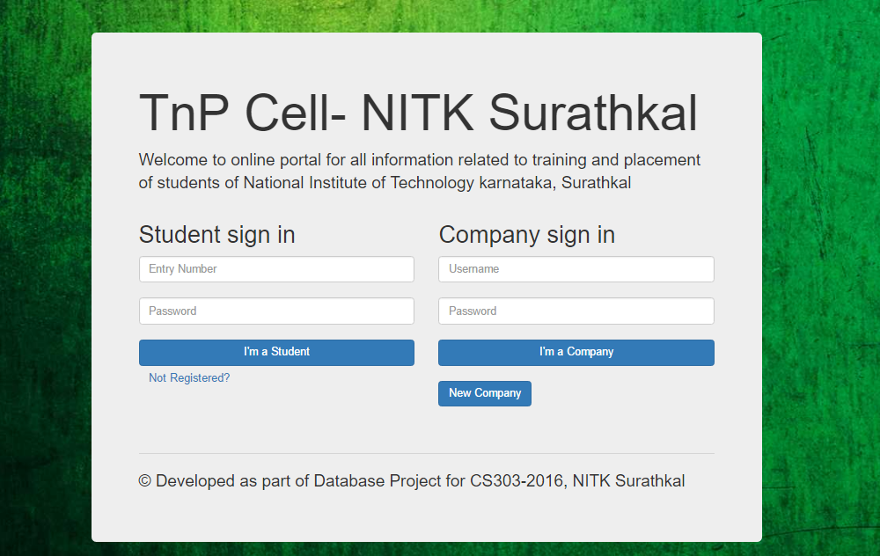

1. **System Modules:**

The system consist of three modules as admin module, student module and recruiter module. Each module has an same login page that contain user id and password field, by entering value in that field the user should login to the system

* 1. **Admin Module:**

The main user of the admin module is TPO of the college. First the user should enter into the admin module of the system by entering valid user-id and password. In the notification tab admin gets registration requests from companies. Once the admin accepts the requests, the company is permitted to participate in the placement programme of the college. The admin also gets interview requests from the companies, if the date and time are not colliding with already accepted interview requests then the admin will accept the request. All the accepted registration requests will be listed in Companies tab in the admin module and all the accepted interviews can be seen in the Interviews scheduled tab with date and time of interview, whether the interview is for placements or training etc., In the statistics tab, branch wise information about the number of students placed, average CGPA, average salary will be listed. After the completion of task user will logout successfully by clicking on logout field at the top menu bar.

***Students:*** List of Students eligible for Placements from admin module.

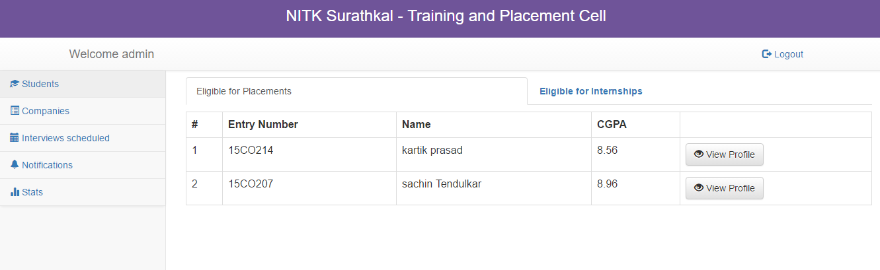

***Companies:*** List of Companies registered for the placement programme.

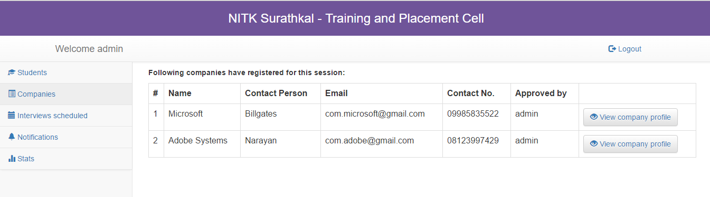

***Interviews Scheduled:*** List of scheduled interviews from admin module.

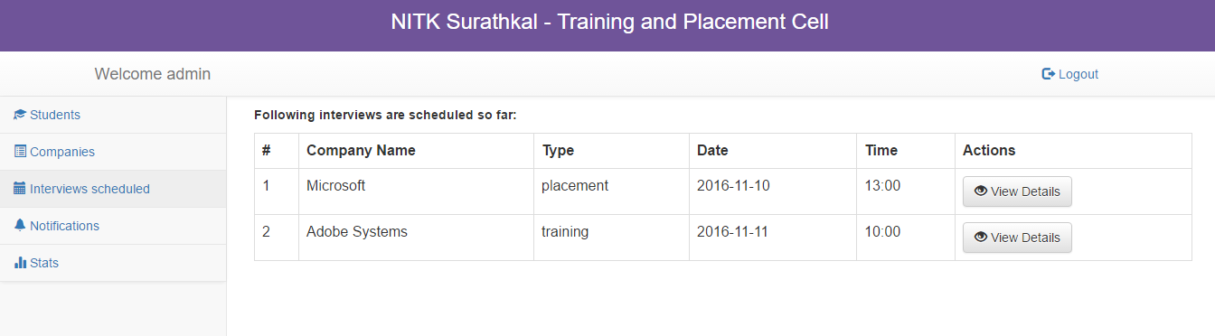

***Statistics:*** Placement statistics of different branches.

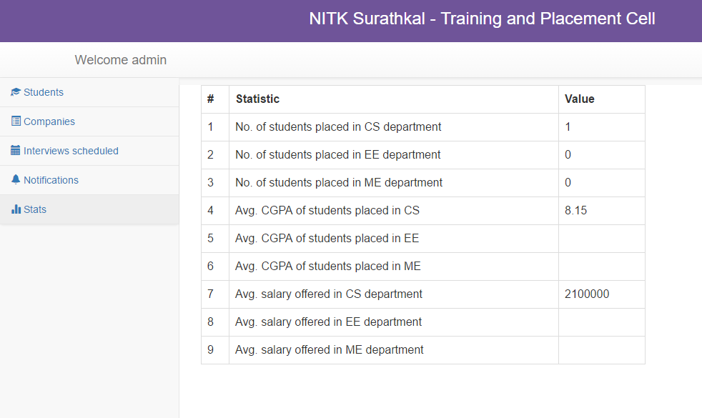

***Notifications:*** Notifications of new registration requests.

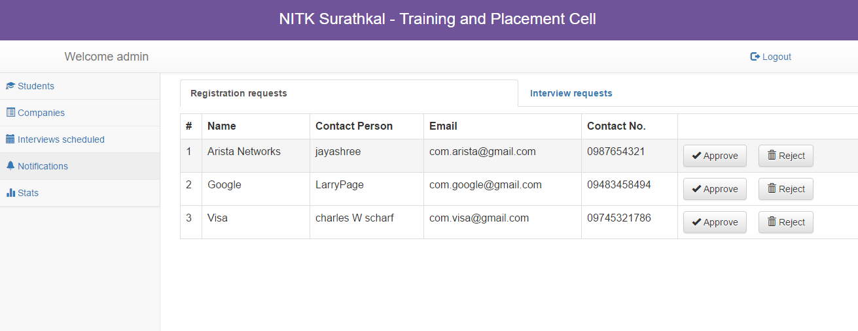

* 1. **Student Module:**

Student module deals with information of student. First student should login into the system by entering user name and password. Student can update his information such as name, branch, year, aggregate marks, contact number, email, etc. by clicking on the Profile option. The student can also update his profile pic and submit the resume. Student can update the information about the courses done by him by clicking courses done tab and then by updating course code and course name. He can also get the information about upcoming companies for interviews by clicking on the Apply option. Based on his CGPA the list of companies he is eligible to apply for interviews will be displayed. The student will also get the notifications if he gets selected in an interview. After completing task successfully by click on the Logout, student can successfully logout from the system.

***Student Profile:*** Student profile page for updating information about student.

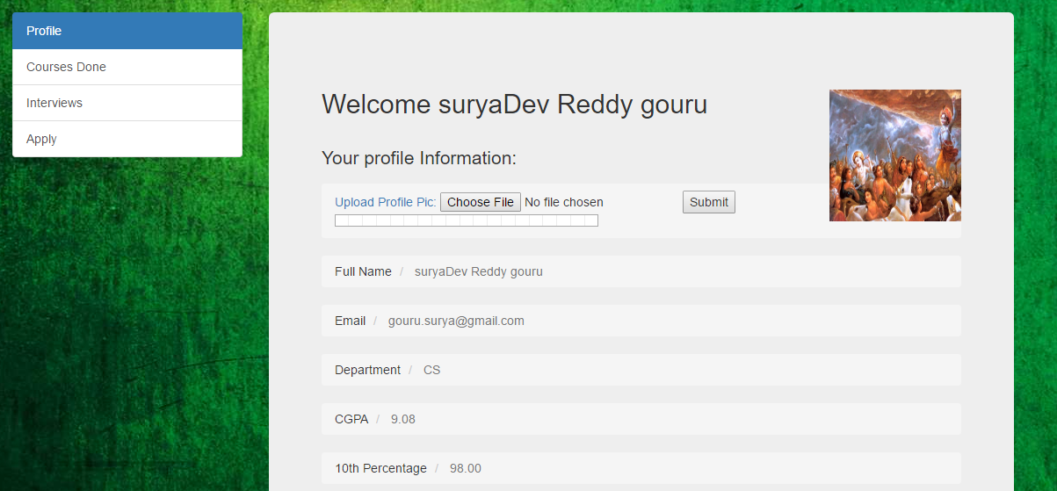

***Courses Completed:*** List of courses completed by the student

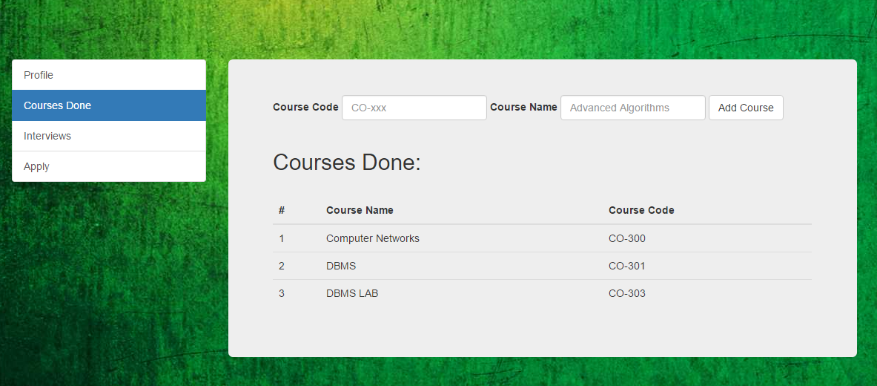

***Interviews:*** List of applied companies from student module.

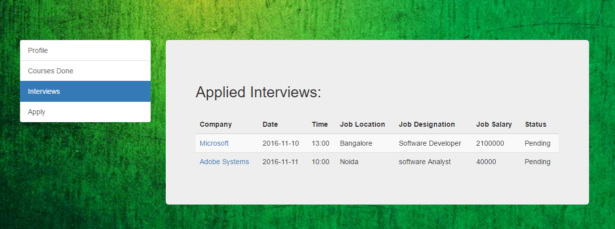

***Apply:*** List of company student is eligible to apply.

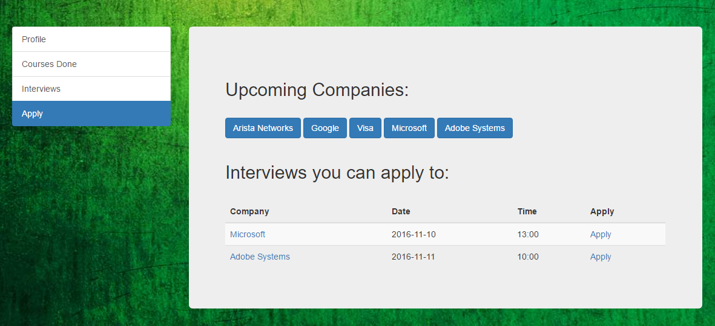

* 1. **Recruiter Module:**

The user of the Company module of the system is the recruiter. Initially recruiter must need to register to the system by entering valid user-id and password and the admin needs to accept this. The recruiter update his details like the company name, contact details, etc., The recruiter can see the details about the college post. The recruiter will also able to see the student details as name, branch, aggregate marks, passed out year etc. He can also view the resume uploaded by the student. He can view the interview requests sent by the students in Interviews option. By clicking on the students option the recruiter can view the list of students who have applied for the interview and can view information. The recruiter can also view the list of students selected in the interview. By clicking on logout field the recruiter can successfully logout from the system

***Company Profile:*** Company profile page for updating information about the company.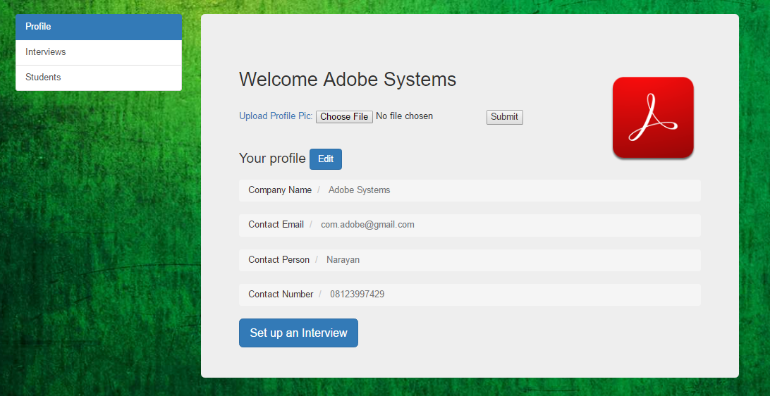

***Interviews:*** List of pending and upcoming interviews to be conducted.

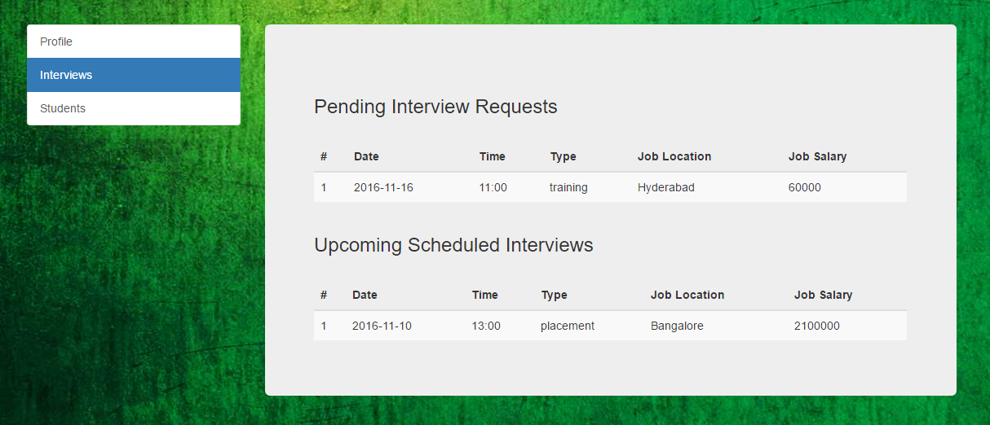

***Students:*** List of students who have applied for interviews and selected students list.

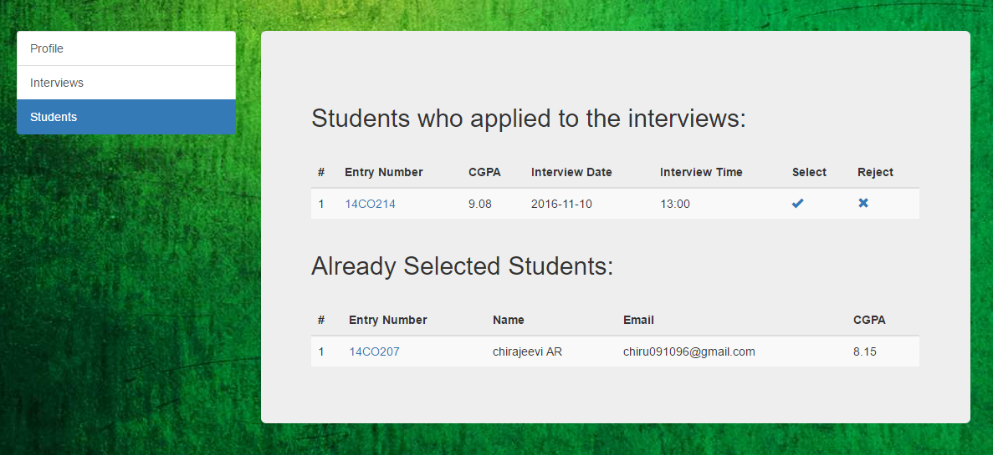

***Feedback:*** Company giving feedback to the selected student

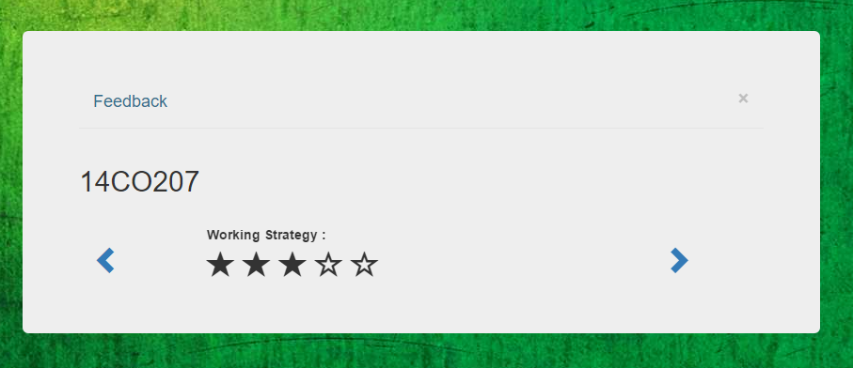

1. **Software Specifications:**

**For Website:**

* Technology Implemented: Wamp Server
* Language Used: PHP 5.2, AJAX
* Database: POSTGRE SQL 5.2
* User Interface Design: HTML, CSS, Javascript, Bootstrap, jQuery
* Web Browser: Chrome,Mozilla,IE8

**For Software Product:**

* Operating System: Windows XP/ 7/8/8.1/10
* Programming Language: PHP
* Software: Wamp Server + Postgresql

1. **Non- Functional Requirements:**

***User-friendly:*** Students will use the forms for their various transactions i.e. for applying interviews, updating course list, editing profile. Also the Student may want to give feedback of company. Companies also use the forms for their various transactions i.e. for setting up interviews, for hiring students, editing profile. Also company can give feedback of selected student. These forms and reports are generated as user-friendly to the Client

***Security:*** The web server and database server should be protected from confidentiality of students and company information etc

***Portability:*** The application is developed using standard open source software like PHP, Apache web server, Internet Explorer Browser etc these software will work both on Windows and Linux o/s. Hence portability problems will not arise.

***Availability:*** This software should be available always

***Economic Feasible:*** Open source software like WAMP, PHP and postgres-sql is used to minimize the cost for the Customer.

1. **Database:**

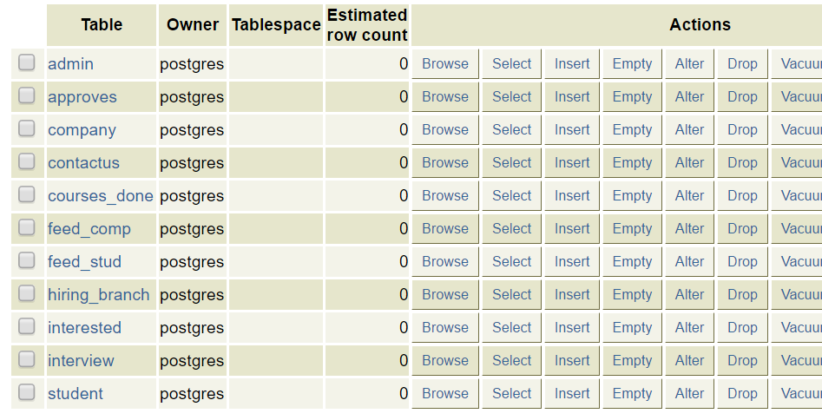

1. **Non- Functional Requirements:**

***User-friendly:*** Students will use the forms for their various transactions i.e. for applying interviews, updating course list, editing profile. Also the Student may want to give feedback of company. Companies also use the forms for their various transactions i.e. for setting up interviews, for hiring students, editing profile. Also company can give feedback of selected student. These forms and reports are generated as user-friendly to the Client

***Security:*** The web server and database server should be protected from confidentiality of students and company information etc

***Portability:*** The application is developed using standard open source software like PHP, Apache web server, Internet Explorer Browser etc these software will work both on Windows and Linux o/s. Hence portability problems will not arise.

***Availability:*** This software should be available always

***Economic Feasible:*** Open source software like WAMP, PHP and postgres-sql is used to minimize the cost for the Customer.

1. **ER Diagram:**

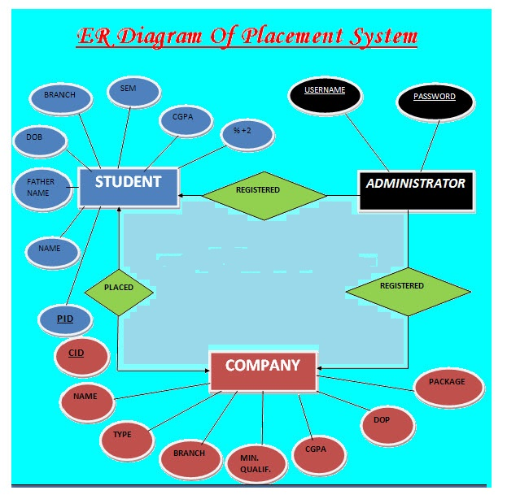

1. **Relational Schema:**
2. **Admin:**

admin (aid, password);

1. **Approves:**

approves (aid, cid);

1. **Company:**

Company (cid, name, password, approval_status, contact_person, contact_email,

contact_number)

1. **ContactUs:**

contactus (name, emailId, subject, message);

1. **Courses_done:**

courses_done (entryno, course_code, course_name);

1. **Feedback_company:**

feedback_comp (employee_attitude, work_strategy, quantity_of_work, quality_of_work, additionally, company_email_id, entry_number);

1. **Feedback_student:**

feedback_stud (work_environment, work_provided, Office_activities, Communication, Monitoring, Additionally, entry_number, company_email_id);

1. **Hiring_branch:**

Hiring_branch (cid, branch, date, time, type);

1. **Interested:**

Interested (cid, date, time, type, entryno, status);

1. **Interview:**

interview(date,time,type,cid,num_of_rounds,resume_shortlist,min_cgpa,min_10th_perce,min_12th_pecen, degree, job_location, job_salary, job_designation, approval_status);

1. **Student:**

Student (entryno,password,first_name,middle_name,last_name,email,department,cgpa,

percen10, percen12, resume_link, applying_for)

1. **Future Enhancements:**

This project is based on complete modular architecture. This modularity of the architecture will allow us to replace or add modules in the future as a way to enhance a particular feature of particular situation. In this case, we can add some features to this software to make this software more reliable. These are as follows:-

* Statistics of placements can be even more realized effectively by plotting bar graphs, pie charts from the data taken from database.
* The searching procedure should be very strong like tpo can search student as fast as possible
* Recruiter can visit any time through this application and communicate with tpo.
* TPO can contact with both student and company through message. Student and company can also send message to TPO

1. **Conclusion:**

System Training and Placement web portal is for computerizing working in a College campus recruitment department. The software takes care of all the requirements of College student and is capable to provide easy and effective information related to student academic session. This project helps a better student support and time saving factor. It also supports better student’s queries and would also provide better reports and information to the management for smooth running

It generates reports that provide description details including various number of student placed in company. It also provides placed student information according to company. The project named Training and Placement is application created in PHP. The project has been developed on the basis of “Placement Cell” being presently used in our college for storing and retrieving the information of students and companies who are registered in placement cell. The Placement Cell maintains a large database of students wherein all the information of student including the personal records and the academic performance in terms of the marks is stored and company information including resume of company and facilities it provide. The software retrieves this data and displays as per the user requirement

**12. Bibliography:**

[1] www.w3schools.com

[2] www.tutorialspoint.com

[3] www.stackoverflow.com

[4] www.youtube.com